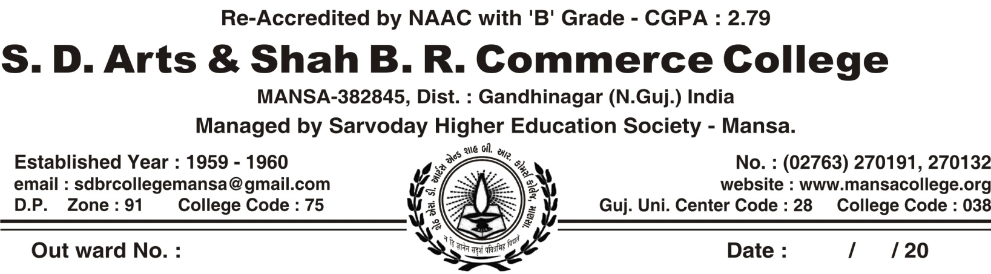

**REGULAR ACTIVITY OF CWDC COMMITTEE, MANSA COLLEGE (2020-21)**

|  |  |  |  |  |
| --- | --- | --- | --- | --- |
| **SR.NO** | **DATE** | **NAME OF ACTIVITY** | **NUMBER OF PARTICIPANTS** | **COLLABORATION WITH** |
|  | 23/10/2020 | Organized Online Quiz On **“Woman Empowerment”** | 225 | By CWDC Committee Of Mansa College itself |
|  | 12/12/2020 | Organized orientation program | 50 | By By CWDC Committee Of Mansa College Itself ,Speaker : Jagrutiben Pandya |
|  | 12/02/2021 | Elocution Competition On  Subject: The Role Of Housewife In The Corona Pandemic  Subject : Essay Competition On Corona Pandemic And Woman | 25 | By CWDC Committee Of Mansa College itself |
|  | 13/2/2021 | Organized lecture on “ laws & women” | 18 | By CWDC Committee Of Mansa College itself  Speaker- Minaxiben K Bhatt |
|  | 8/3/2021 | Webinar on “vyakti rupen sanshita” on INTERNATIONAL WOMAN DAY | 116 | Speaker- Margi Hathi |

**Elocution Competition On**

**Subject: The Role Of Housewife In The Corona Pandemic 12/2/2021**

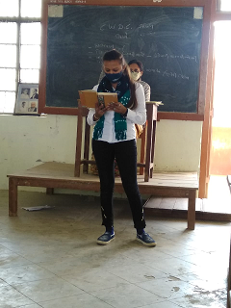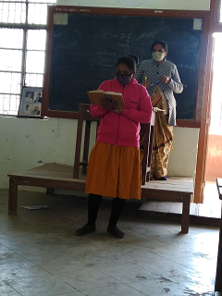

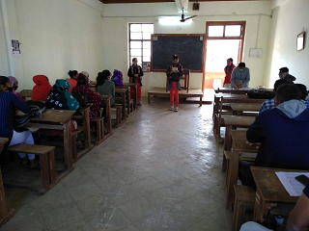

**Organized lecture on “laws & women”**

**Speaker- Minaxiben Bhatt 13/3/2021**

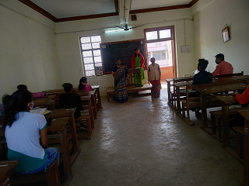

**Webinar On “Vyakti Rupen Sanshita” On INTERNATIONAL WOMAN DAY**

**8/3/2021 Speaker - Dr. Margi Hathi**

